**Experiment 2 Date:**

**Aim:**

Find the current through all the resistors using Super position theorem and verify the same by simulation.

**Statement:** The Superposition theorem is applicable to circuits consisting of more than one active source. The theorem states that the current through or voltage across an element in a linear bilateral active network is equal to algebraic sum of the currents through or voltage drop across the element independently by each source.

**Components Required:**

DC Voltage Source, Voltage Measurement, Current Measurement, Series RLC Branch, Display, Powergui(continuous), scope (for graph).

**Procedure:**

1. Connect the resistors with voltage measurement and current measurement in parallel and series respectively.
2. Assign the values for resistors.
3. Form a complete circuit by connecting DC voltage source.
4. Connect display boxes for the current measurement and voltage across each resistor.
5. For the circuit to run add or connect powergui

**Circuit Diagram:**

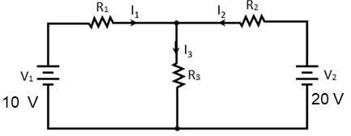

**Simulation Diagram:**

**Considering 100v:**

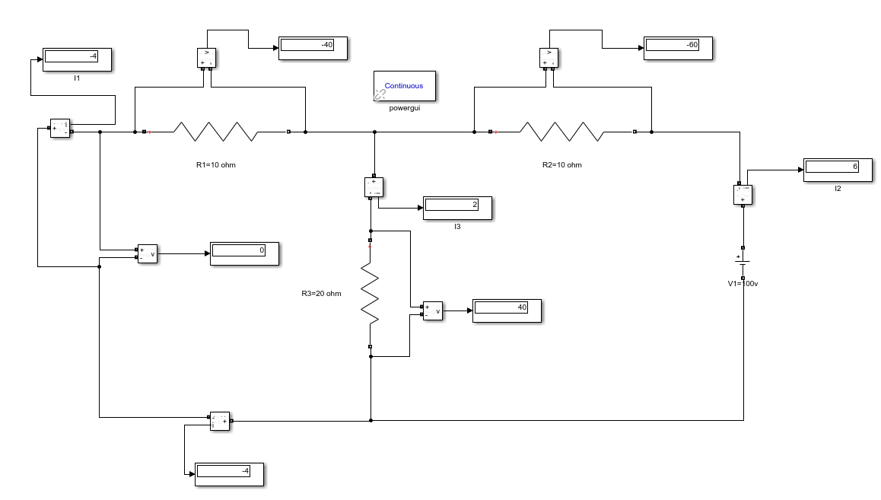

**Considering 50v:**

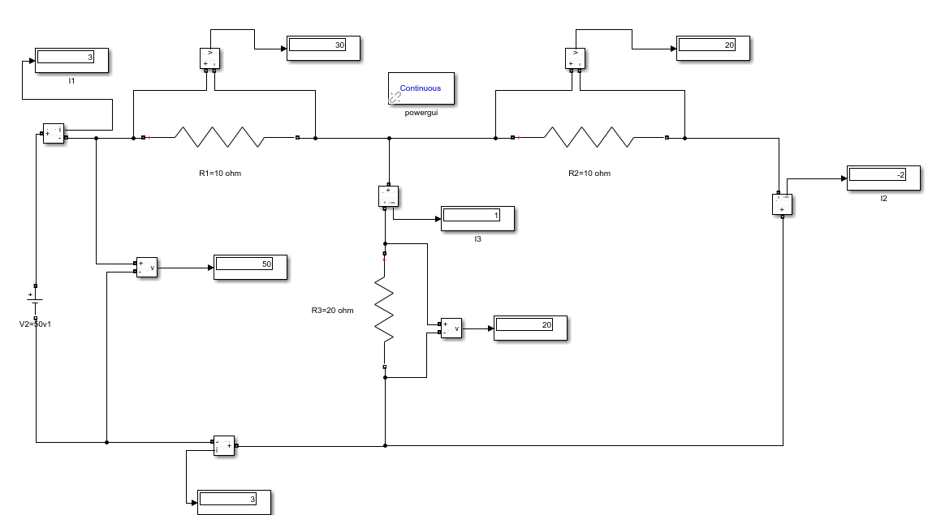

**Considering both 100 and 50v:**

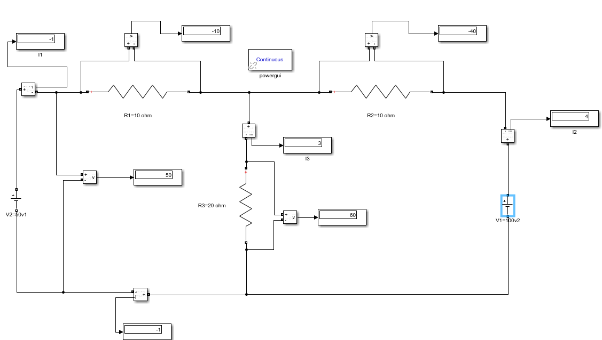

**Tabular Column:**

|  |  |  |  |  |  |  |
| --- | --- | --- | --- | --- | --- | --- |
| Source | I1 | | I2 | | I3 | |
| **Th** | **Pr** | **Th** | **Pr** | **Th** | **Pr** |
| V1= 100V V2=50V |  |  |  |  |  |  |
| V1=100V  (Alone) |  |  |  |  |  |  |
| V2=50V  (Alone) |  |  |  |  |  |  |

**Result :**

Hence the Superposition Principle is verified as I1' + I1'' =I1,

I2' + I2'' =I2 and I3' + I3'' =I3.